**Udemy MapReduce Introduction Lecture**

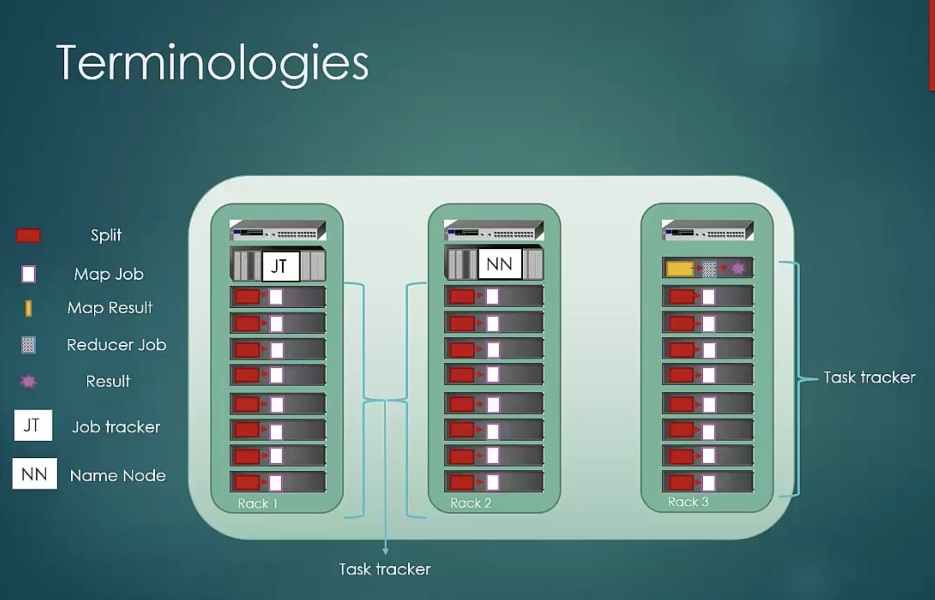

JT = Job Tracker

TT = Task Tracker

Node having JT is called Master Node and nodes having TT are called Slave Nodes.

HDFS’s NameNode calls Job Tracker and Job Tracker manages Task Trackers. Task Trackers are nothing but Mapper classes. So Mapper class is installed in each TT node when you run MapReduce.

Task Trackers are on every HDFS Data Node and its responsibility is to run MapReduce and send updates to Job Tracker.

Job Tracker takes care of scheduling tasks to be run on Task Trackers. Job Tracker knows which job is running on which Task Tracker etc.

Not to be confused with HDFS's NameNode. NameNode is responsible for keeping metadata of each block stored in DataNode, whereas JT and TT are part of MapReduce. JT's responsibility is to keep metadata of tasks(jobs) running and to be run on TTs.

JT and TT are Java processes running on the machines, they are not the hardwares. Like NN's failure is the most serious one in HDFS, JT's failure is the most serious one in MapReduce because JT knows everything about the tasks running on TTs. So, it is better to use good hardware for JT (Master Node).

**Entire MapReduce process:**

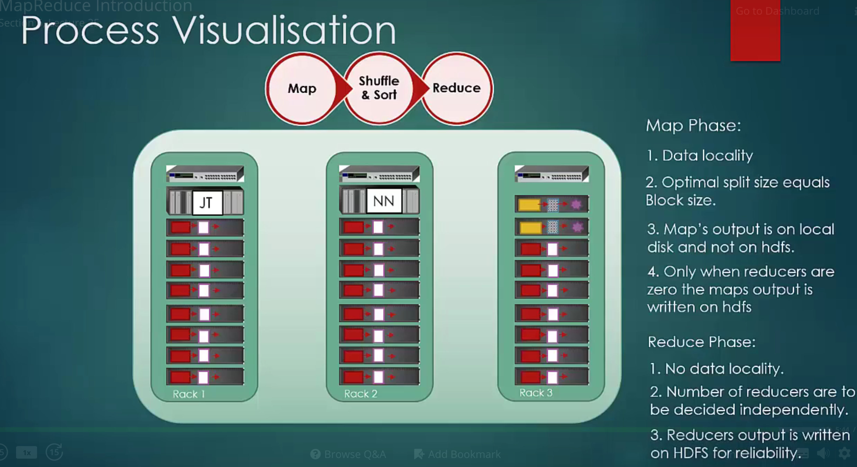

InputSplit is an input to Map Job. Each Map job produces output and this output goes through shuffling and sorting and stored into local disk. This outputs become input to Reducer which produces final output.

Optimal value of a InputSplit size will be equal to a block size in HDFS data node. Every Map job gets input from its own data node.

Map Job runs on each data node and the result of Map jobs are stored in Local Disk (not HDFS). Then this output is given to Reducer through network (so there is some latency), who merges output from each Map job and Sorts them by keys. This is called Shuffle and Sort phase. Reducer's output comes after a lot of processing, so it needs to stored reliably on HDFS itself.

Once Reducer task is finished successfully, Map jobs' output is discarded by JT from the local disk. Local disk can fail, but in HDFS, data can be replicated. So, HDFS is more resilient for hardware failures.

By default, split size is same as block size, but you can configure it. Formula to decide split size=max(mapred.min.split.size, min(mapred.max.split.size, dfs.block.size)).

So, you can control split size using **mapred.min.split.size**.

Number of Map jobs will be equal to number of Splits. Each split will be given to a single Map. **InputFormat** class decides the split size . **RecordReader** class creates key-value pairs from the split and stores them in context. Mapper's **run()** method reads this key-value one by one and processes it and creates output in the form of key-value again.

**What is InputSplit, InputFormat and RecordReader in MapReduce?**

http://hadooptutorial.info/hadoop-input-formats/

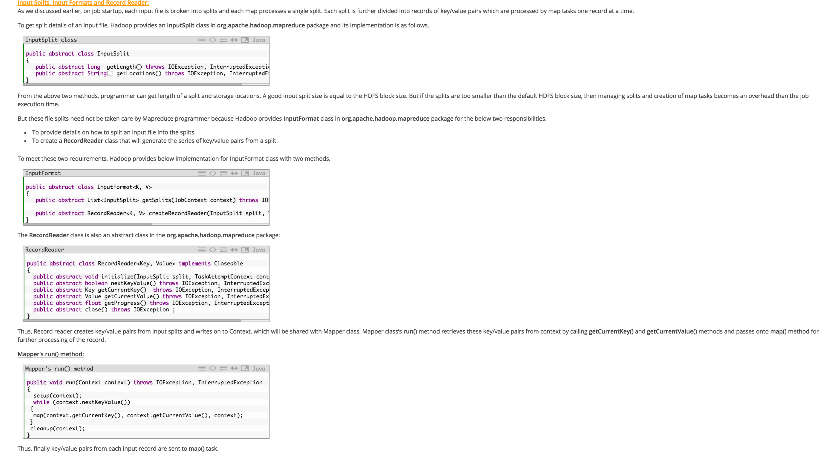

InputFormat's getSplit function generate a List of InputSplit, from the List of files defined in JobContext.

**What is importance of RecordReader in Hadoop?**

<https://www.youtube.com/watch?v=1BvJ3ouk3gg>

**What types of key,value pairs will be generated, if our file format is TextInputFormat?**

<https://www.youtube.com/watch?v=tAIRyO__Uwg>

Default InputFormat is TextInputFormat, whose RecordReader will consider each line of the split as key-value pair by default. You can customize RecordReader to consider more than 1 lines also as value.

Default key will be byte offset (LongWritable type) and value (Text type) will be entire line.

e.g. InputSplit has following lines

hi how are you

I am fine

TextInputFormat’s RecordReader will create two key-value pairs.

(0, hi how are you)

(14, I am fine) --- /n will also be considered as a byte. So, next line doesn’t start from 13.

These key-value pairs will be stored in context and Mapper will read this key-value pair one by one and process it.

Mapper will process values and based on logic written in Mapper, it will create another key-value pairs

e.g. if Mapper’s logic is to count number of each letter in the InputSplit then

Mapper’s output will be

(h, 2) (i, 2)

(i, 1) (a, 1)

…

Mapper creates key-value output for each input key-value.

If you don’t write your own Mapper, Hadoop uses implicit Mapper called IdentityMapper that does nothing but its output is same as input.

So, output’s key will be of type of Text and value will be type of IntWritable.

Shuffling is a step that combines all values of same key in one key-value. E.g. there are two key-value pairs of key ‘i’, shuffling will combine into one (i, [1,2]).

After Shuffling, Sorting will be done based on keys.

Shuffling and Sorting are done by Reducer.

If there is no Reducer, Shuffling and Sorting phase will not run.

If you don’t write your own Reducer, Hadoop will use implicit IdentityReducer that will do only Sorting (no Suffling).

Just like Mapper, Reducer also takes each key-value as input one by one. So, Reducer will run as many times as number of key-value created by all mappers.

Each key-value will be input to Reducer.

Think of a situation where you have crores of key-value pairs generated by each Mapper. To read these key-value pairs from local disk and pass them one by one to Reducer will take very long time because of network traffic and performance will go down.

To overcome this situation, Combiner is given. It does Shuffling and Sorting for each Mapper’s output. So, number of key-value pairs to be written to local disk reduces probably from crores to lacs.

Number of combiners will be same as number of Mappers.

If you have multiple Reducers, Partitioner will decide which key-value pair should go to which Reducer. There is an implicit HashPartitioner that decides Reducer based on key’s hashcode. You can write your own Partitioner also.

Process Visualization of Partitioner

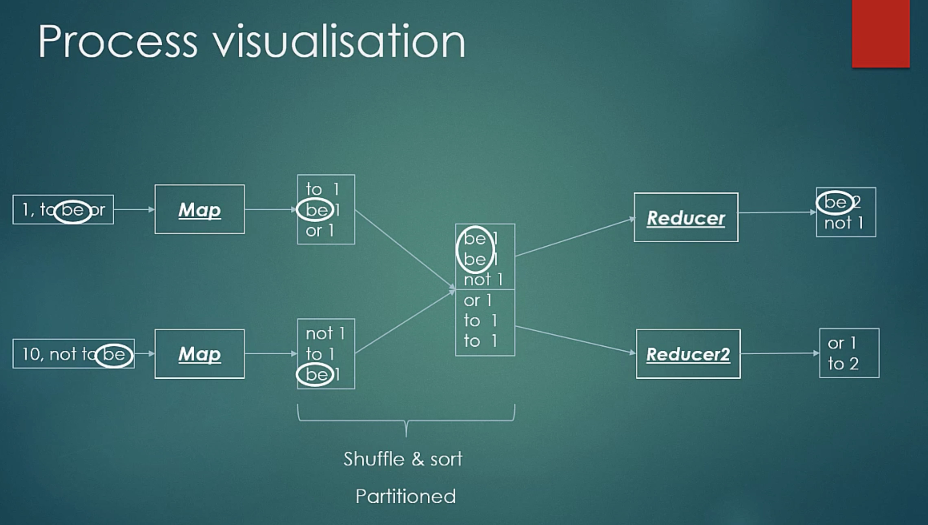

Process Visualization of Combiner

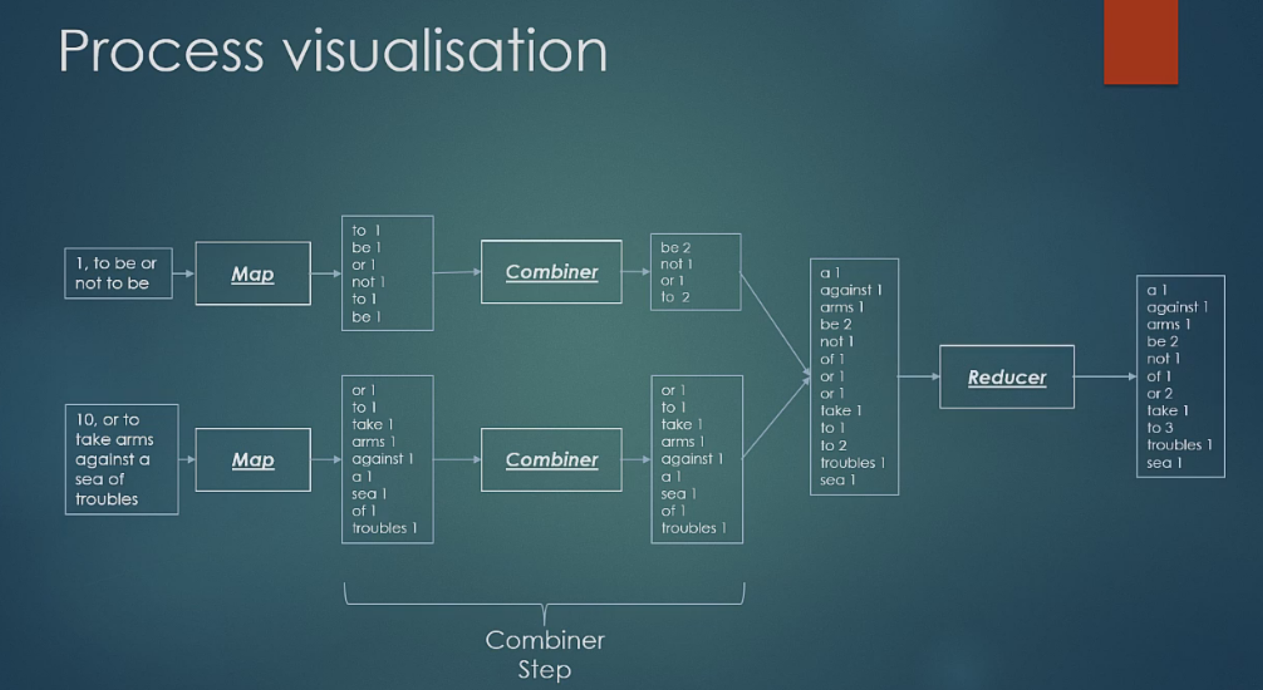

Combiner’s code is exactly same as Reducer and it does exactly the same thing as Reducer. The only difference is that Combiner is on the same node where Mapper is. By doing reduction of Mapper’s output using Combiner reduces total output to be transferred through network to a Reducer. This is a key advantage of Combiner.

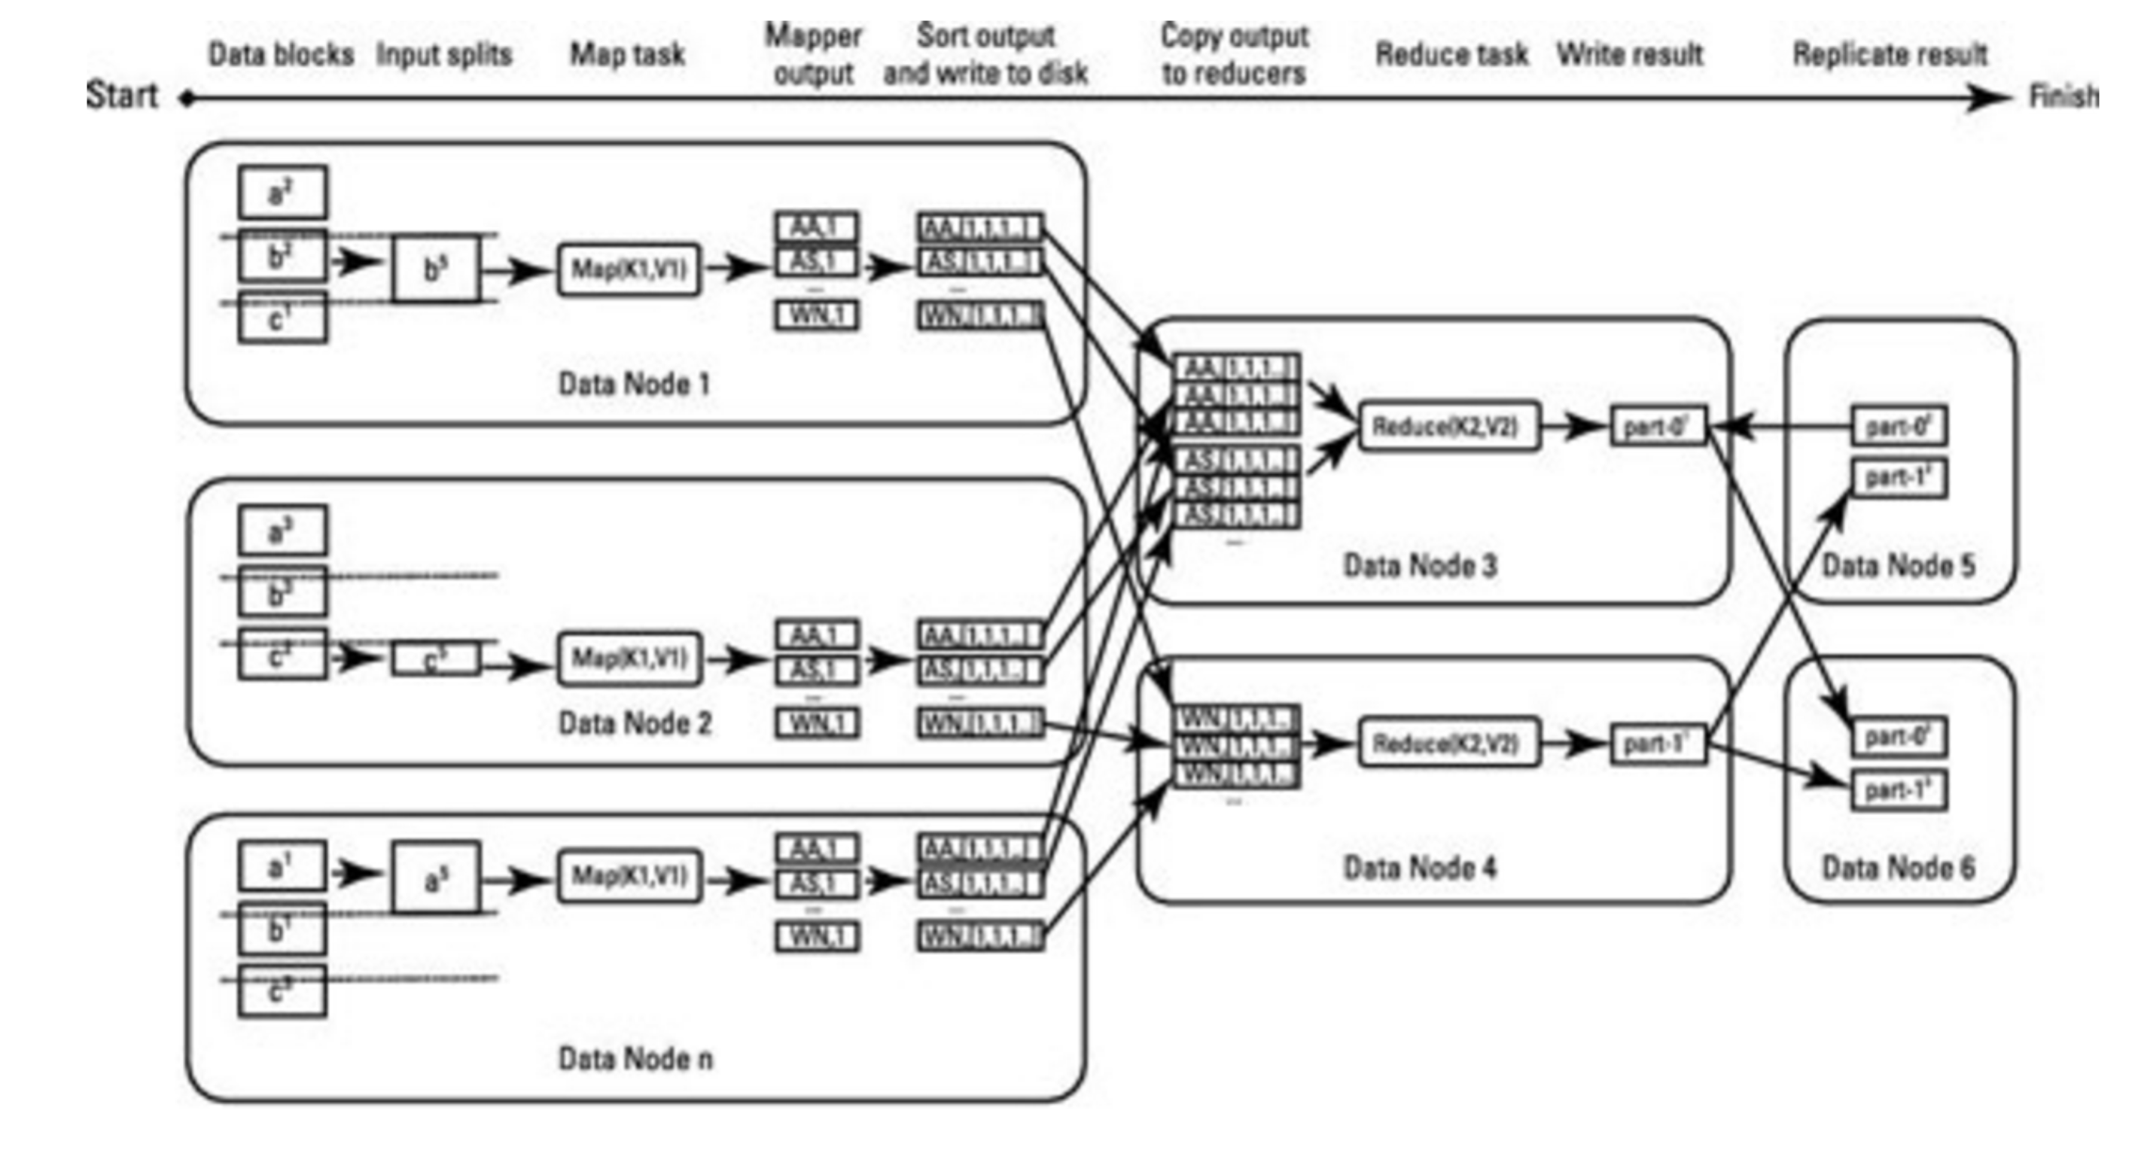



**Map phase** is done by mappers.

***Mappers*** run on unsorted input key/values pairs. Each mapper emits zero, one or multiple output key/value pairs for each input key/value pairs.

**Combine** phase is done by **Combiners**. Combiner should combine key/value pairs with the same key together. Each combiner may run zero, once or multiple times.

Combiner’s code is exactly same as Reducer and it does exactly the same thing as Reducer. The only difference is that Combiner is on the same node where Mapper is. By doing reduction of Mapper’s output using Combiner reduces total output to be transferred through network to a Reducer. This is a key advantage of Combiner.

**Partitioner** decides which Reducer will get a particular key value pair. **It is partitioner’s responsibility to do Shuffle and Sort.**

**Shuffle and Sort phase** is done by framework. Data from all mappers are grouped by the key, split among reducers and sorted by the key. Each reducer obtains all values associated with the same key. Programmer may supply custom compare function for sorting and **Partitioner** for data split.

**Reducer** obtains sorted key/[values list] pairs sorted by the key. Value list contains all values with the same key produced by mappers. Each reducer emits zero, one or multiple output key/value pairs for each input key/value pair.

**Interaction between JobClient, JobTracker, TaskTracker and HDFS**

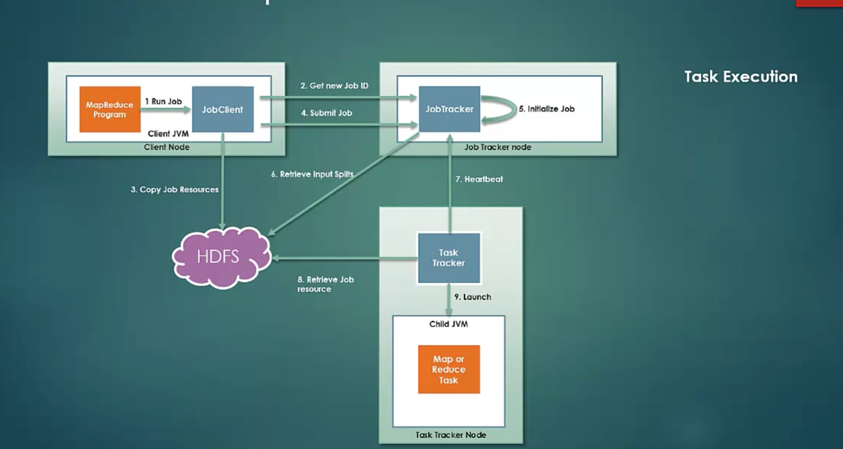

JobClient is nothing but DriverClass program that creates Job instance, which has

InputFormat type

Mapper, Combiner, Reducer classes

Output Key-Value types

etc.

JobClient (DriverClass) gets a New JobId from JobTracker

Then it copies the resources like Mapper,Combiner,Reducer programs etc to HDFS with high replication mode.

Then it submits the job to JobTracker.

JobTracker initializes a Job.

Then it takes the help of InputFormat given by JobClient to calculate the InputSplits and accordingly initializes the number of Mappers.

It is continuously getting the HeartBeats from TaskTrackers. It submits the job to TaskTracker which is available and not loaded by other job works.

TaskTracker retrieves Mapper,Combiner,Reducer etc programs from HDFS and creates a new JVM instance for a new job. During the run of the job, it constantly keeps sending the status to JobTracker.

On completion of the Reducer task, it cleans up the intermittent data created by Mapper on local disc.

Finally, JobTracker sends a job completion code back to JobClient. That’s why JobClient(Driver Class) code has job.waitForCompletion() method.

See how HDFS responds when MapReduce reads or writes the data from and to it. I have put this picture here just to explain end to end picture of Hadoop.

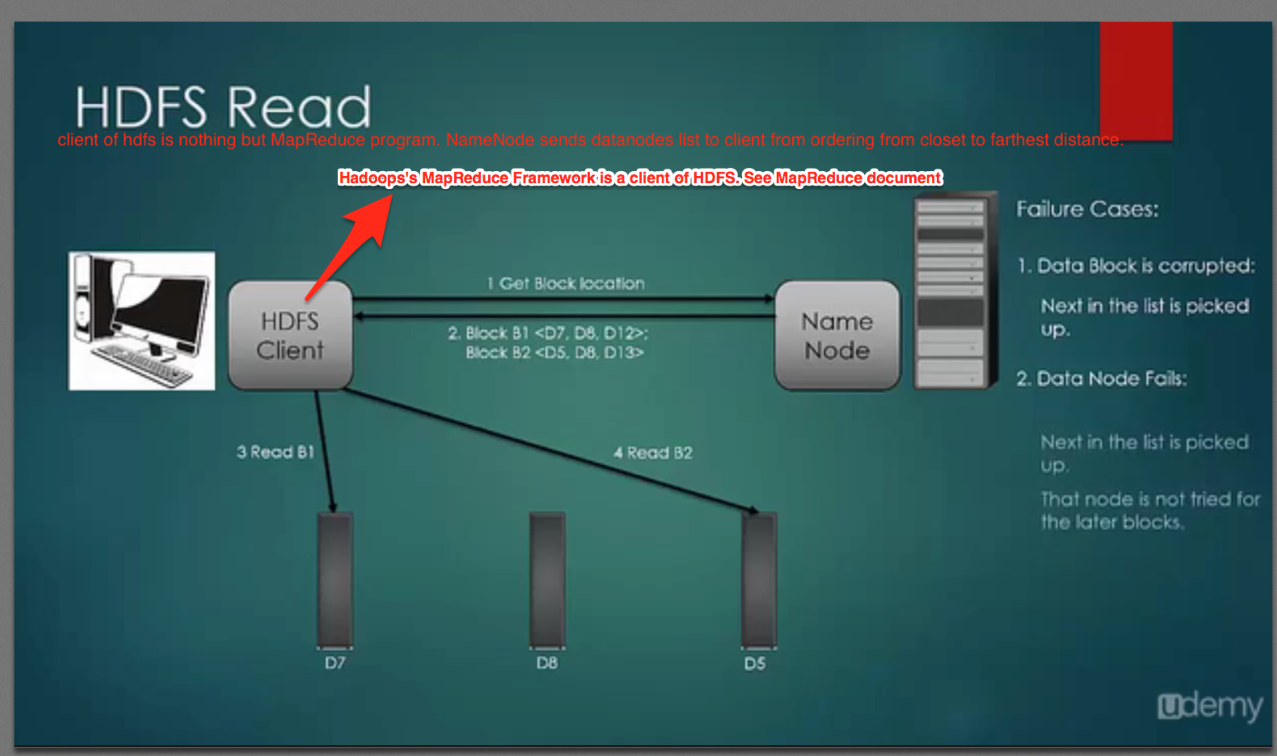

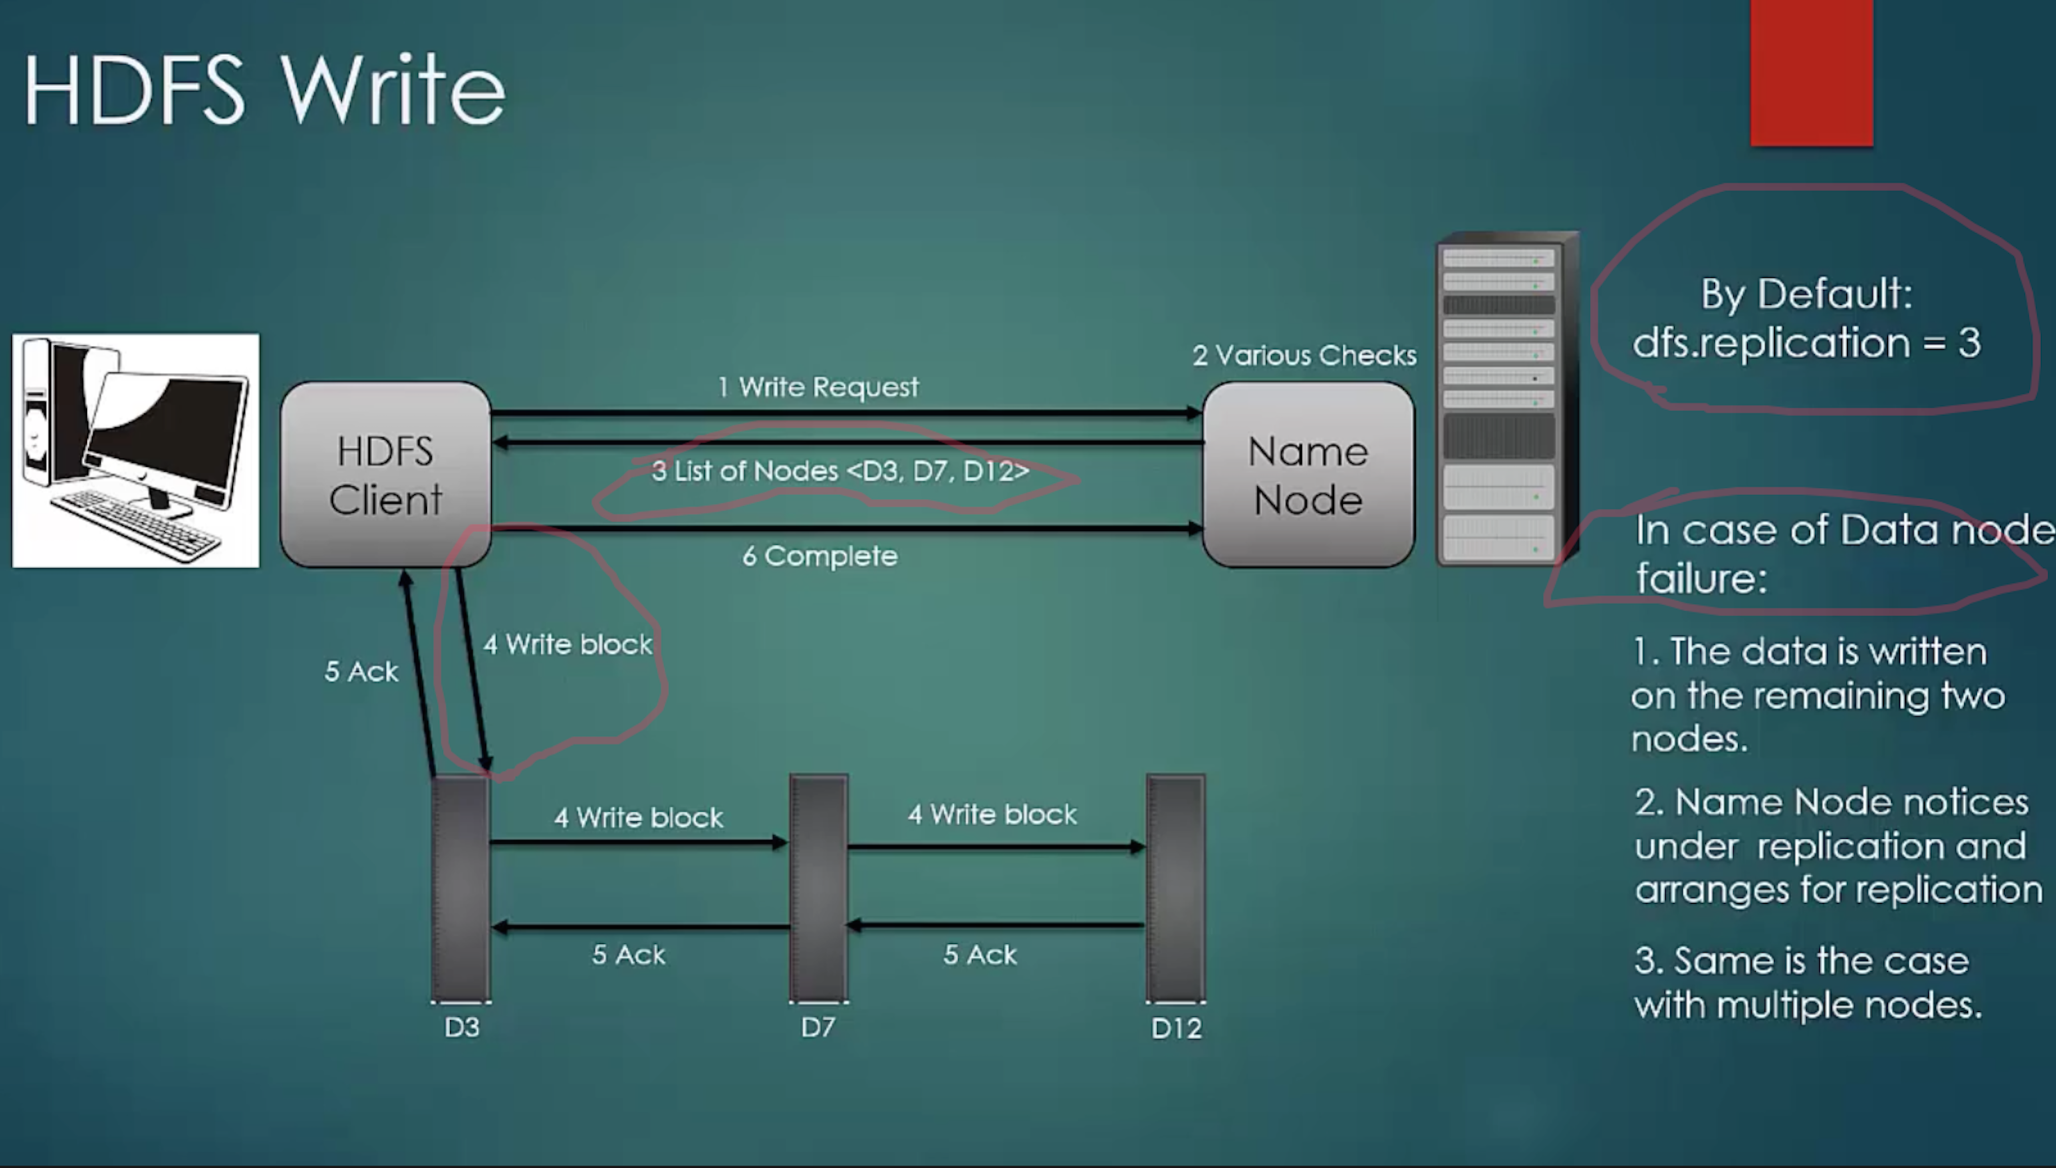

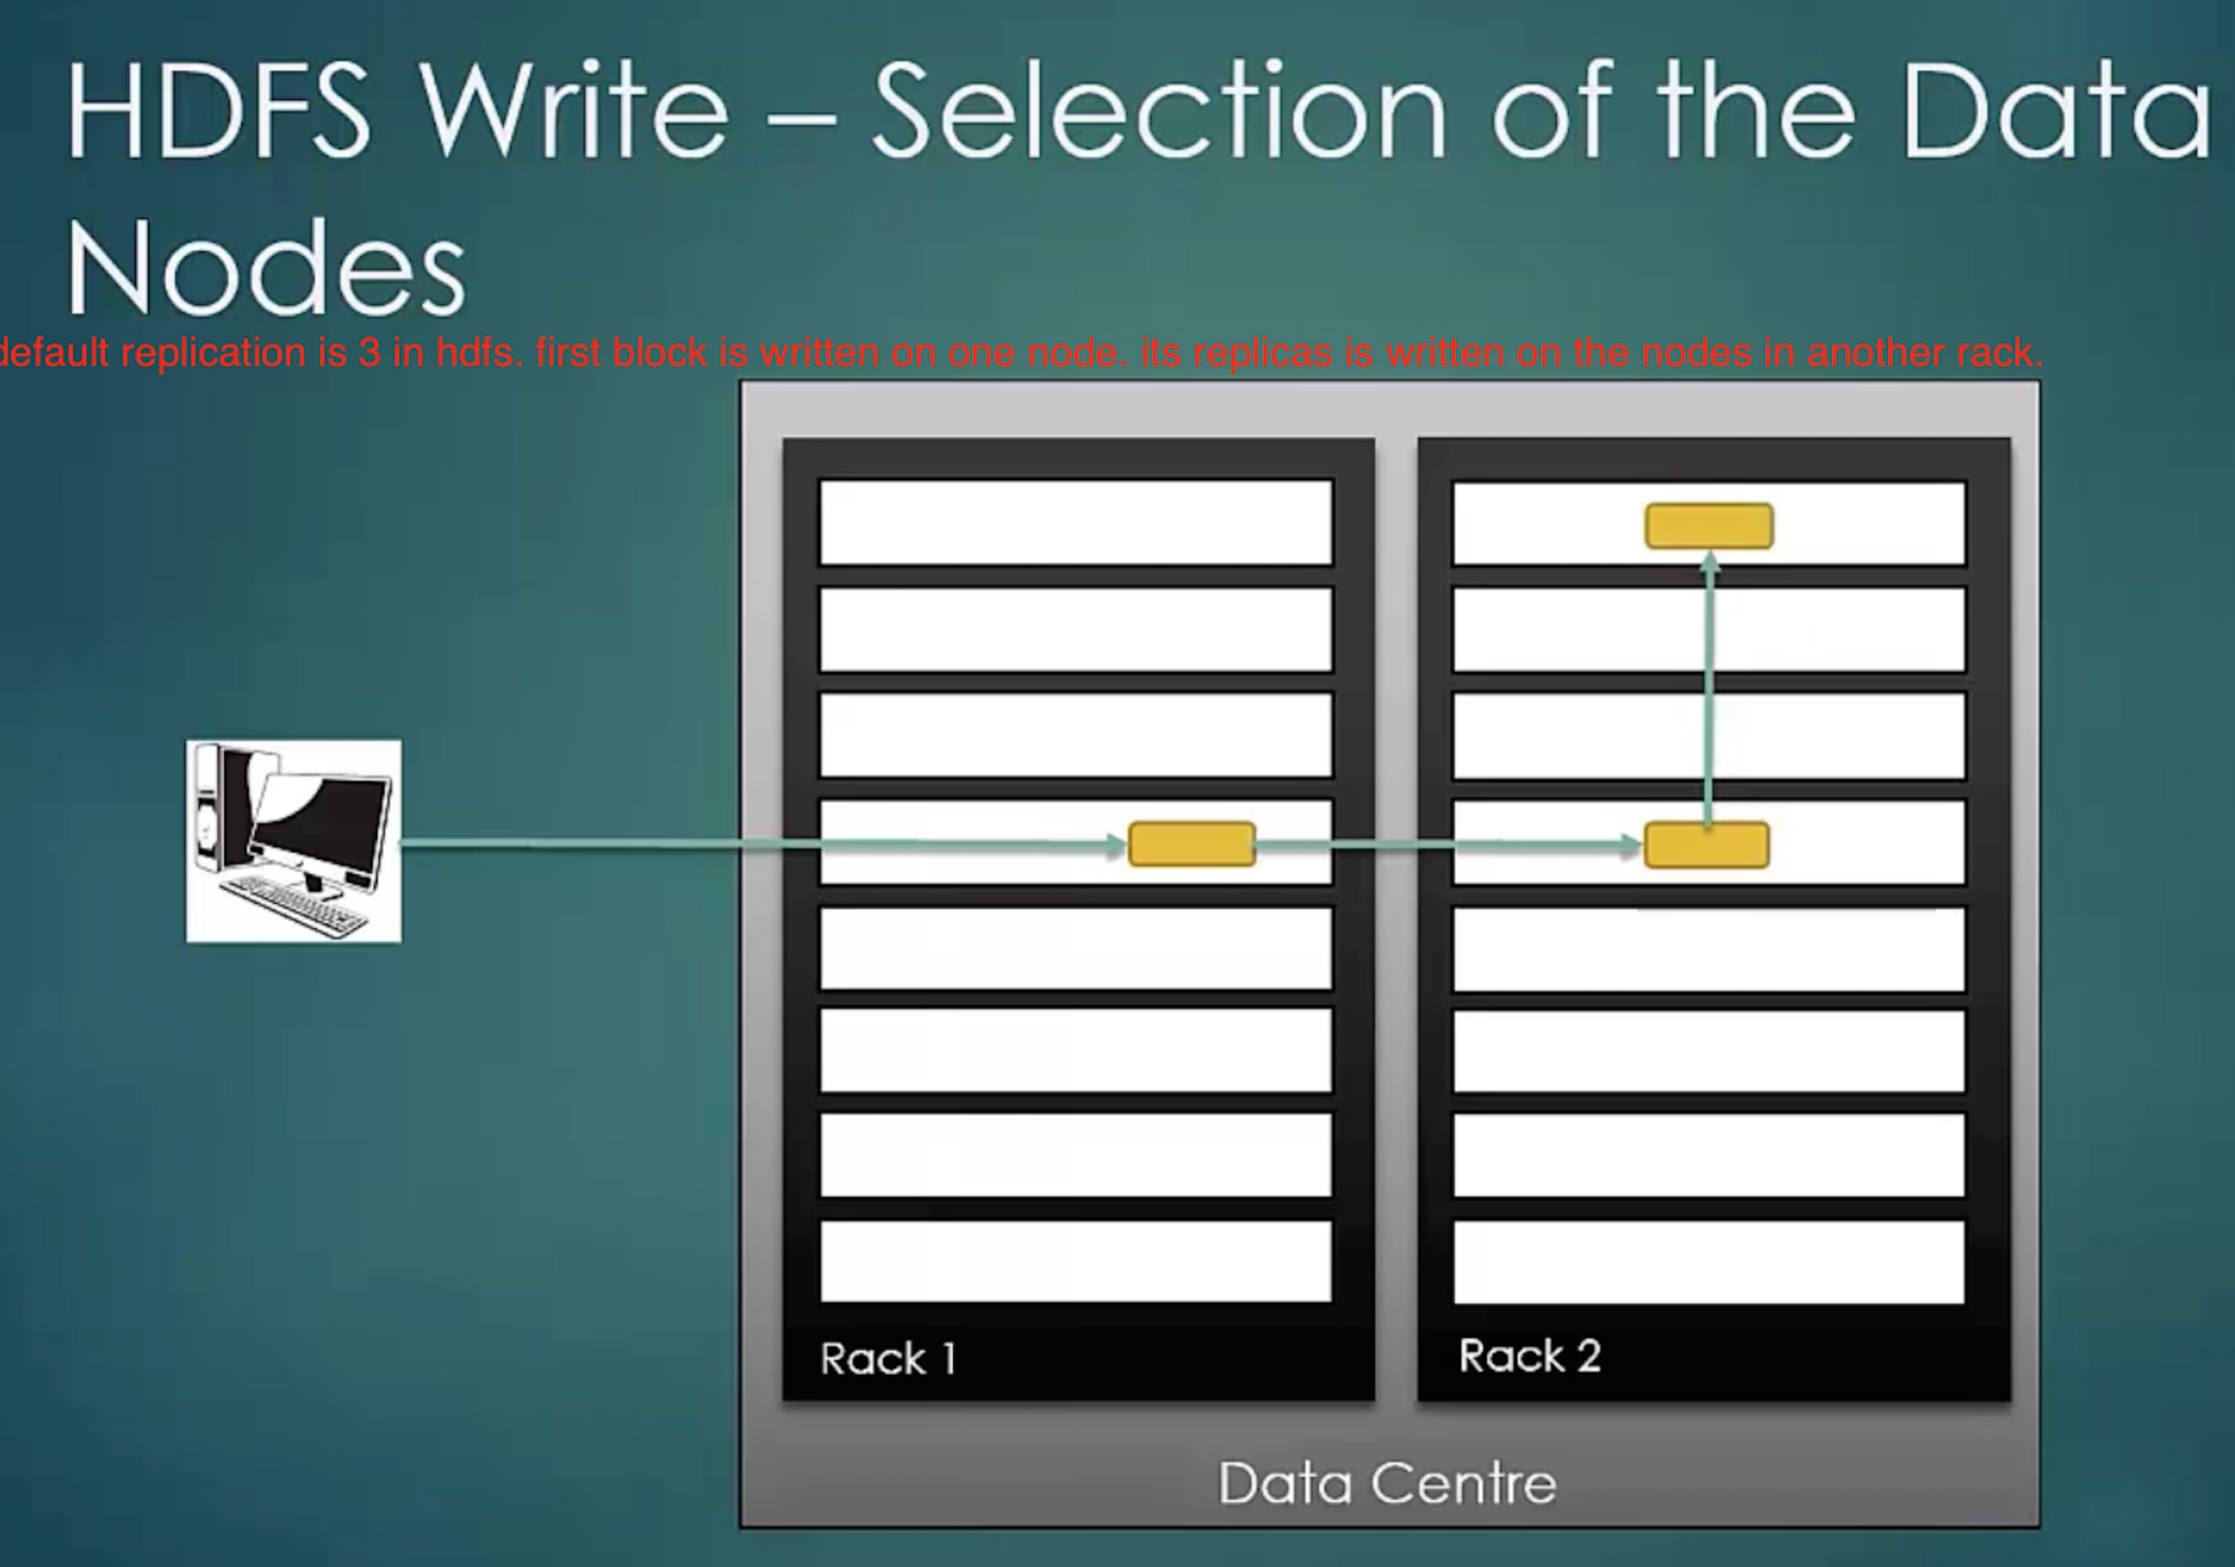

**MapReduce Failure Cases**

Case 1: Code written for Mapper or Reduce goes in infinite loop. In this case, TaskTracker will mark that job as failed based on a property value set by ‘**mapred.task.timout’**. If this property is set to 0, TaskTracker will never fail a long running job. This is not suggested. It will bring down the overall performance of the cluster.

Case 2: JVM that is running a program crashes or hardware crashes, in this case JobTracker know that failure is not because of the code, so, it will resubmit the job to another available TaskTracker.

Number of attempts of resubmitting the job to another TaskTracker is decided by **‘mapred.map.max.attempts’** property, default value is 4. Similarly, there is ‘**mapred.reduce.map.attempts’**

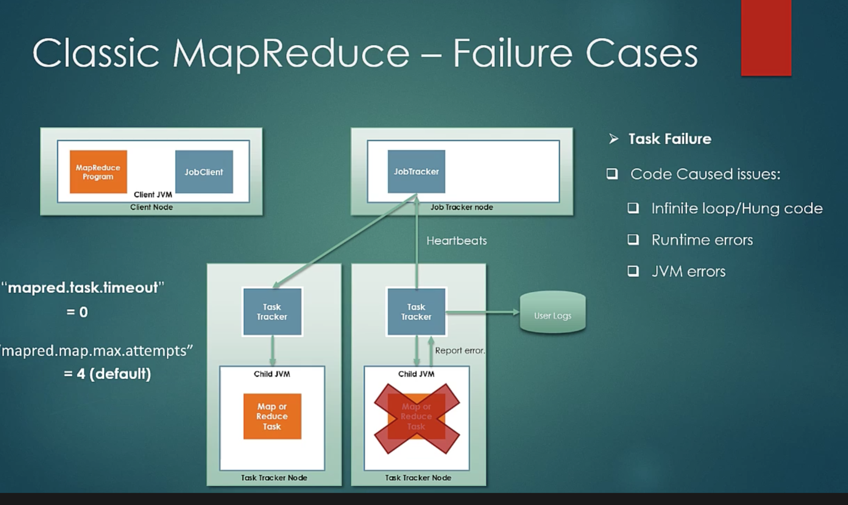

Case3: TaskTracker failure. TaskTracker is also a java process only. It can fail and in that case it stops sending heartbeats to JobTracker. JobTracker blacklists that TaskTracker and resubmit the job to another TaskTracker.

Another reason for blacklisting the TaskTracker could be high number of job failures from a particular TaskTracker. In this case, JobTracker black lists it for a while and considers it again after some time or on restart. Max number of allowed task tracker failures can be set using **‘mapred.max.tracker.failures’** property.

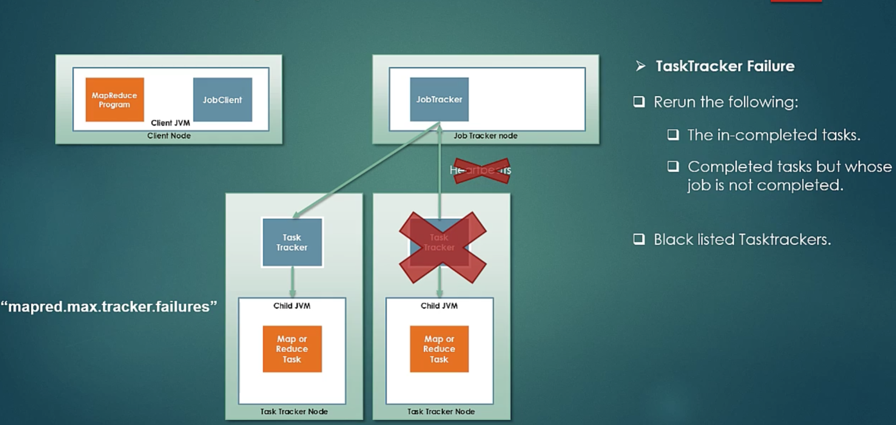

Case4 : Failure of a JobTracker. It is the most dangerous scenario because it’s a single point of failure in Classic MapReduce (Hadoop1). So, JobTracker should be running on a good hardware.

This situation is little improved in Hadoop2 with YARN, which is also called MapReduce2. You can read more about YARN in **‘Hadoop1 and Hadoop2.docx’**

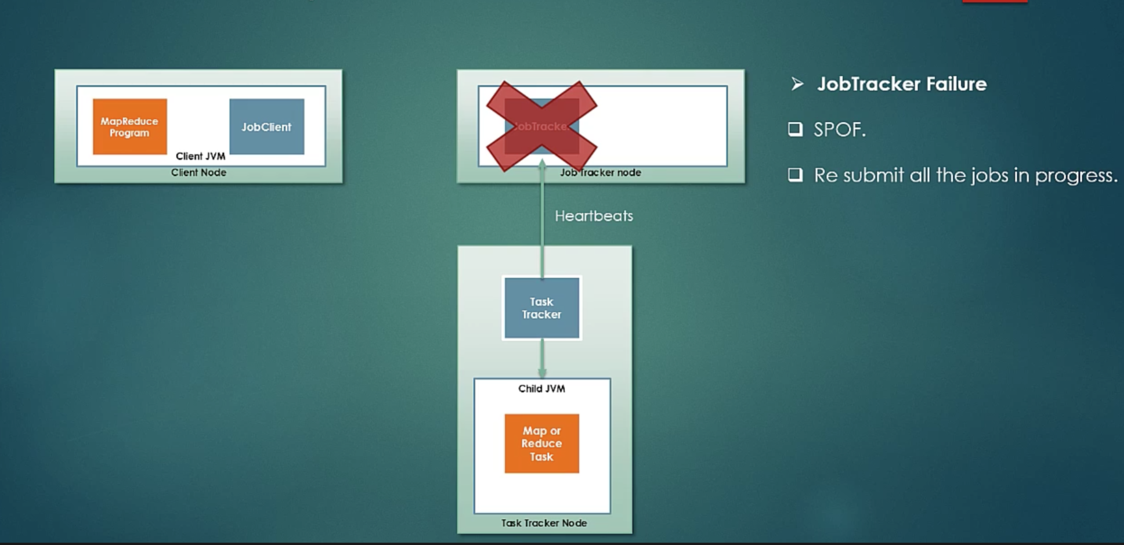

**Job Schedulers Types**

1) First In first Out (FIFO) – Default in Hadoop1

It is available only in Hadoop1

2) Capacity Scheduler – Default in Hadoop2 as FIFO is not available in Hadoop2

3) Fair Scheduler

See “Hadoop1 vs Hadoop2 Self Created Document.docx” for more information.

**Serialization and Deserialization**

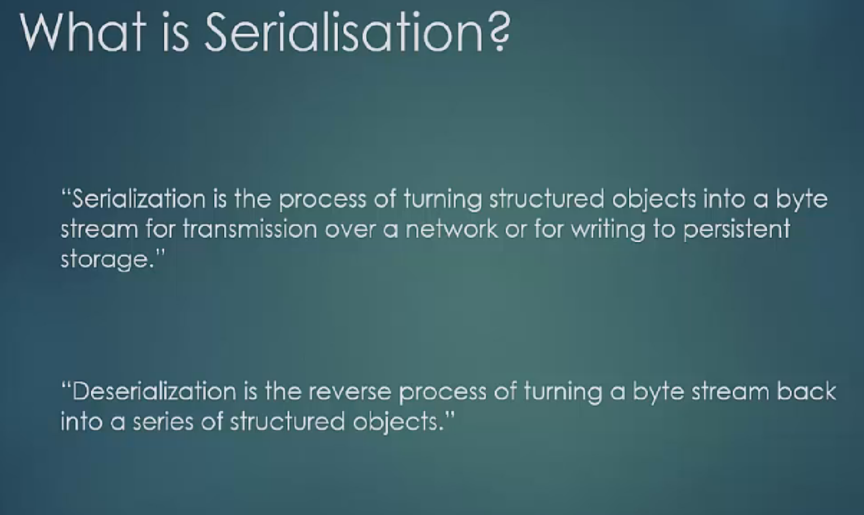

Data needs to be serialized to send it across the network to Reducers or for writing to persistent storage.

Data transfer in Hadoop happens through RPC (Remote Procedure Call).

Sequence of events during an RPC

<https://en.wikipedia.org/wiki/Remote_procedure_call>

* The client calls the client stub. The call is a local procedure call, with parameters pushed on to the stack in the normal way.
* The client stub packs the parameters into a message and makes a system call to send the message. Packing the parameters is called marshalling.
* The client's local operating system sends the message from the client machine to the server machine.
* The local operating system on the server machine passes the incoming packets to the server stub.
* The server stub unpacks the parameters from the message. Unpacking the parameters is called unmarshalling.
* Finally, the server stub calls the server procedure. The reply traces the same steps in the reverse direction.

**Can we set required no of mappers and required no of reducers?**

<https://www.youtube.com/watch?v=kF122tPGGys>

We should not set number of Mappers. Old API used to allow it to set in JobConf, but new API doesn’t allow it. Because number of mappers should not be decided by client, it should be decided by Job Tracker based on number of InputSplits.

We can definitely decide number of Reducers. By default, there will be only 1 Reducer, but you can set it to more or even 0.

If there are 0 reducers then output of Mappers will be final outputs.

If there are 2 reducers then there will be 2 output files.

The number of ReduceTasks for the job is decided by the configuration parameter “mapreduce.job.reduces”

**MapReduce Flow Chart**

<https://www.youtube.com/watch?v=6OemZEJdMp8>

InputFormats are of following types

FileInputFormat --- reads input from HDFS file.

DBInputFormat --- A InputFormat that reads input data from an SQL table.

ComposableInputFormat --- Refinement of InputFormat requiring implementers to provide

ComposableRecordReader instead of RecordReader.

CompositeInputFormat --- An InputFormat capable of performing joins over a set of data sources sorted and partitioned the same way.

Types of FileInputFormat

* TextInputFormat (Default)
  + key will be offset of line (LongWritable type) and value will be line (Text type)
* KeyValueTextInputFormat
  + before first tab, it will be a key (Text type) and after first tab it will be value (Text type)
* SequenceFileInputFormat
* SequenceFileAsTextInputFormat

InputFormat creates InputSplits.

InputFormat has getRecordReader() method.

RecordReader will read one line at a time (by default) from InputSplit, but depending on type of InputFormat, it will decide what should be key and value. This key-value will be input to a Mapper.

For TextInputFormat, RecordReader will create key-value of byte offset of a starting of line and value will be a line.

Data Types of Key and Value-

Each key and value has some type. Just like how java has introduced Wrapper classes for each primitive type, hadoop has introduced Box classes. So when RecordReader of TextInputFormat creates key-value pair, it will be type of LongWritable-Text.

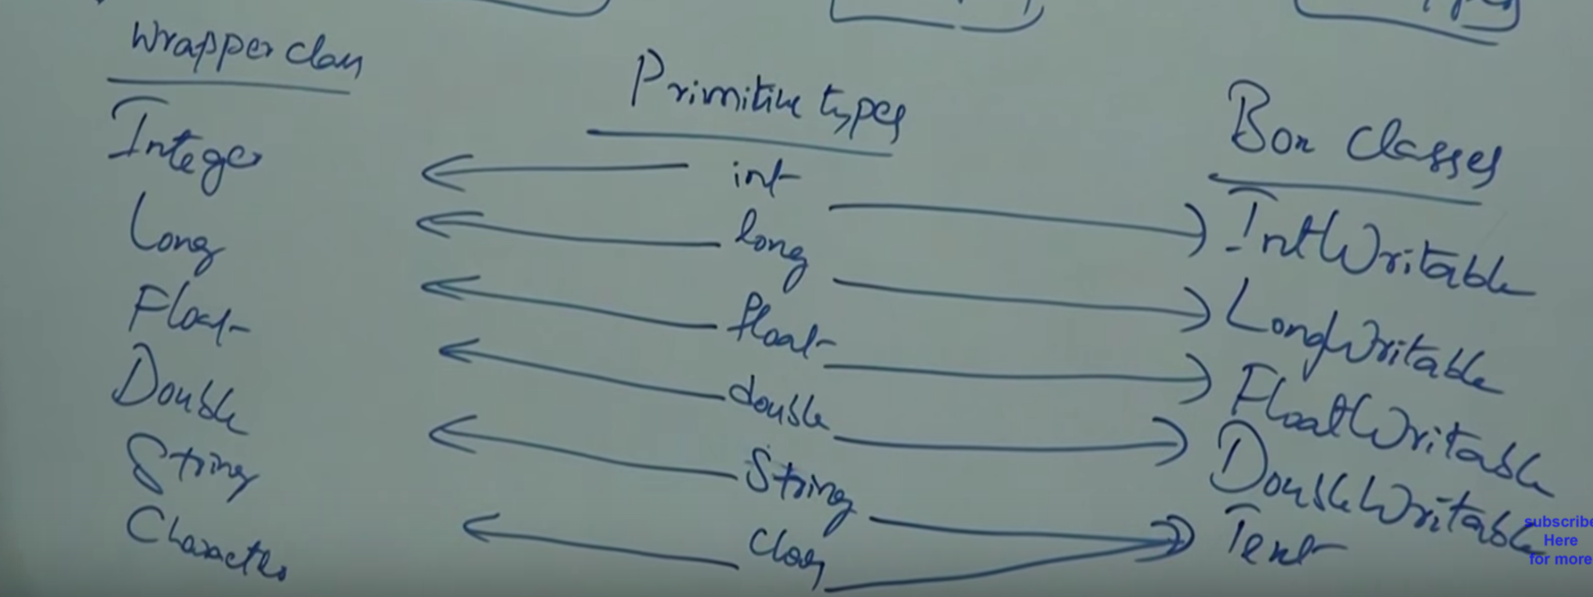

All these wrapper classes are given to work with Collection.

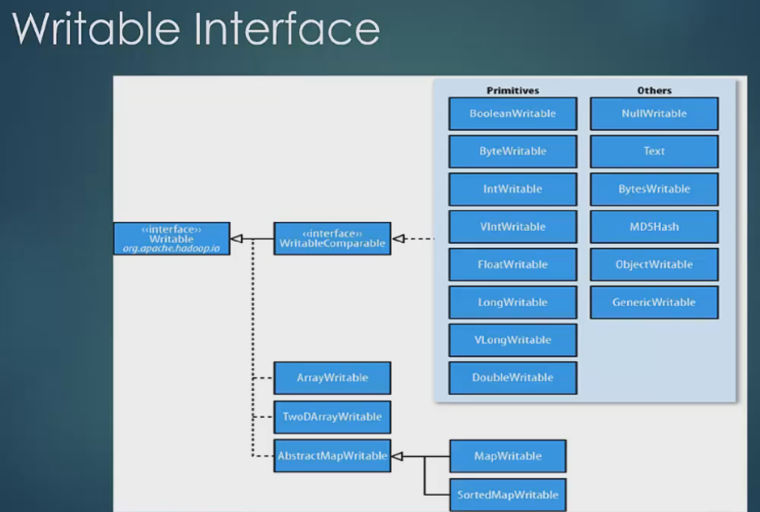

Why Hadoop could not use Java’s Serialization framework? Why Hadoop could not use Java’s wrapper classes like Integer, Long, String etc and why it had to come up with its own wrapper classes?

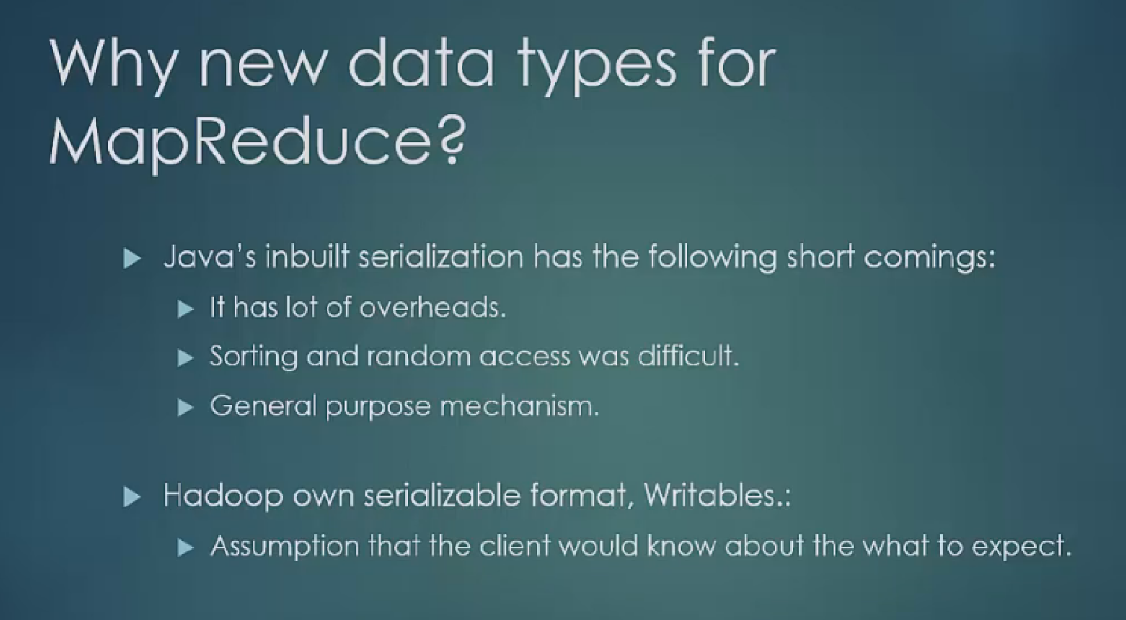

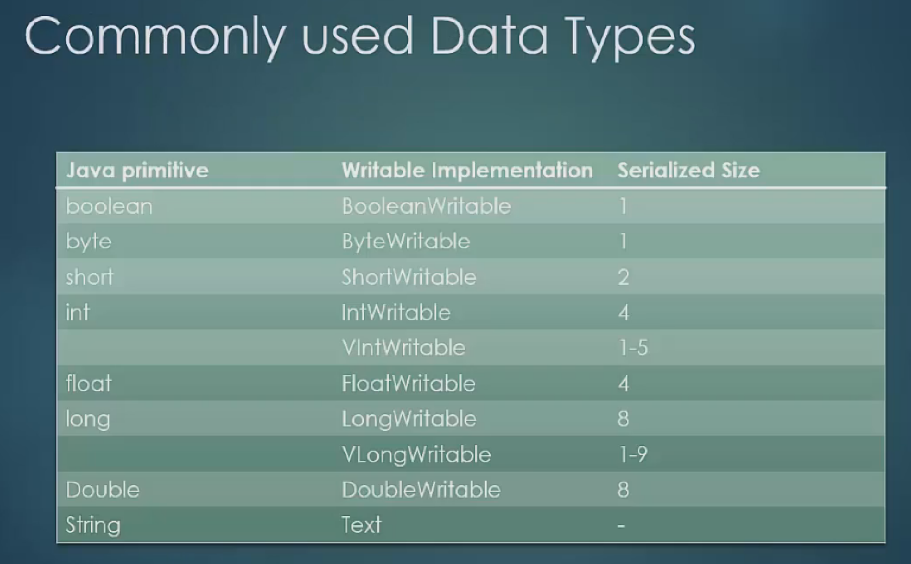

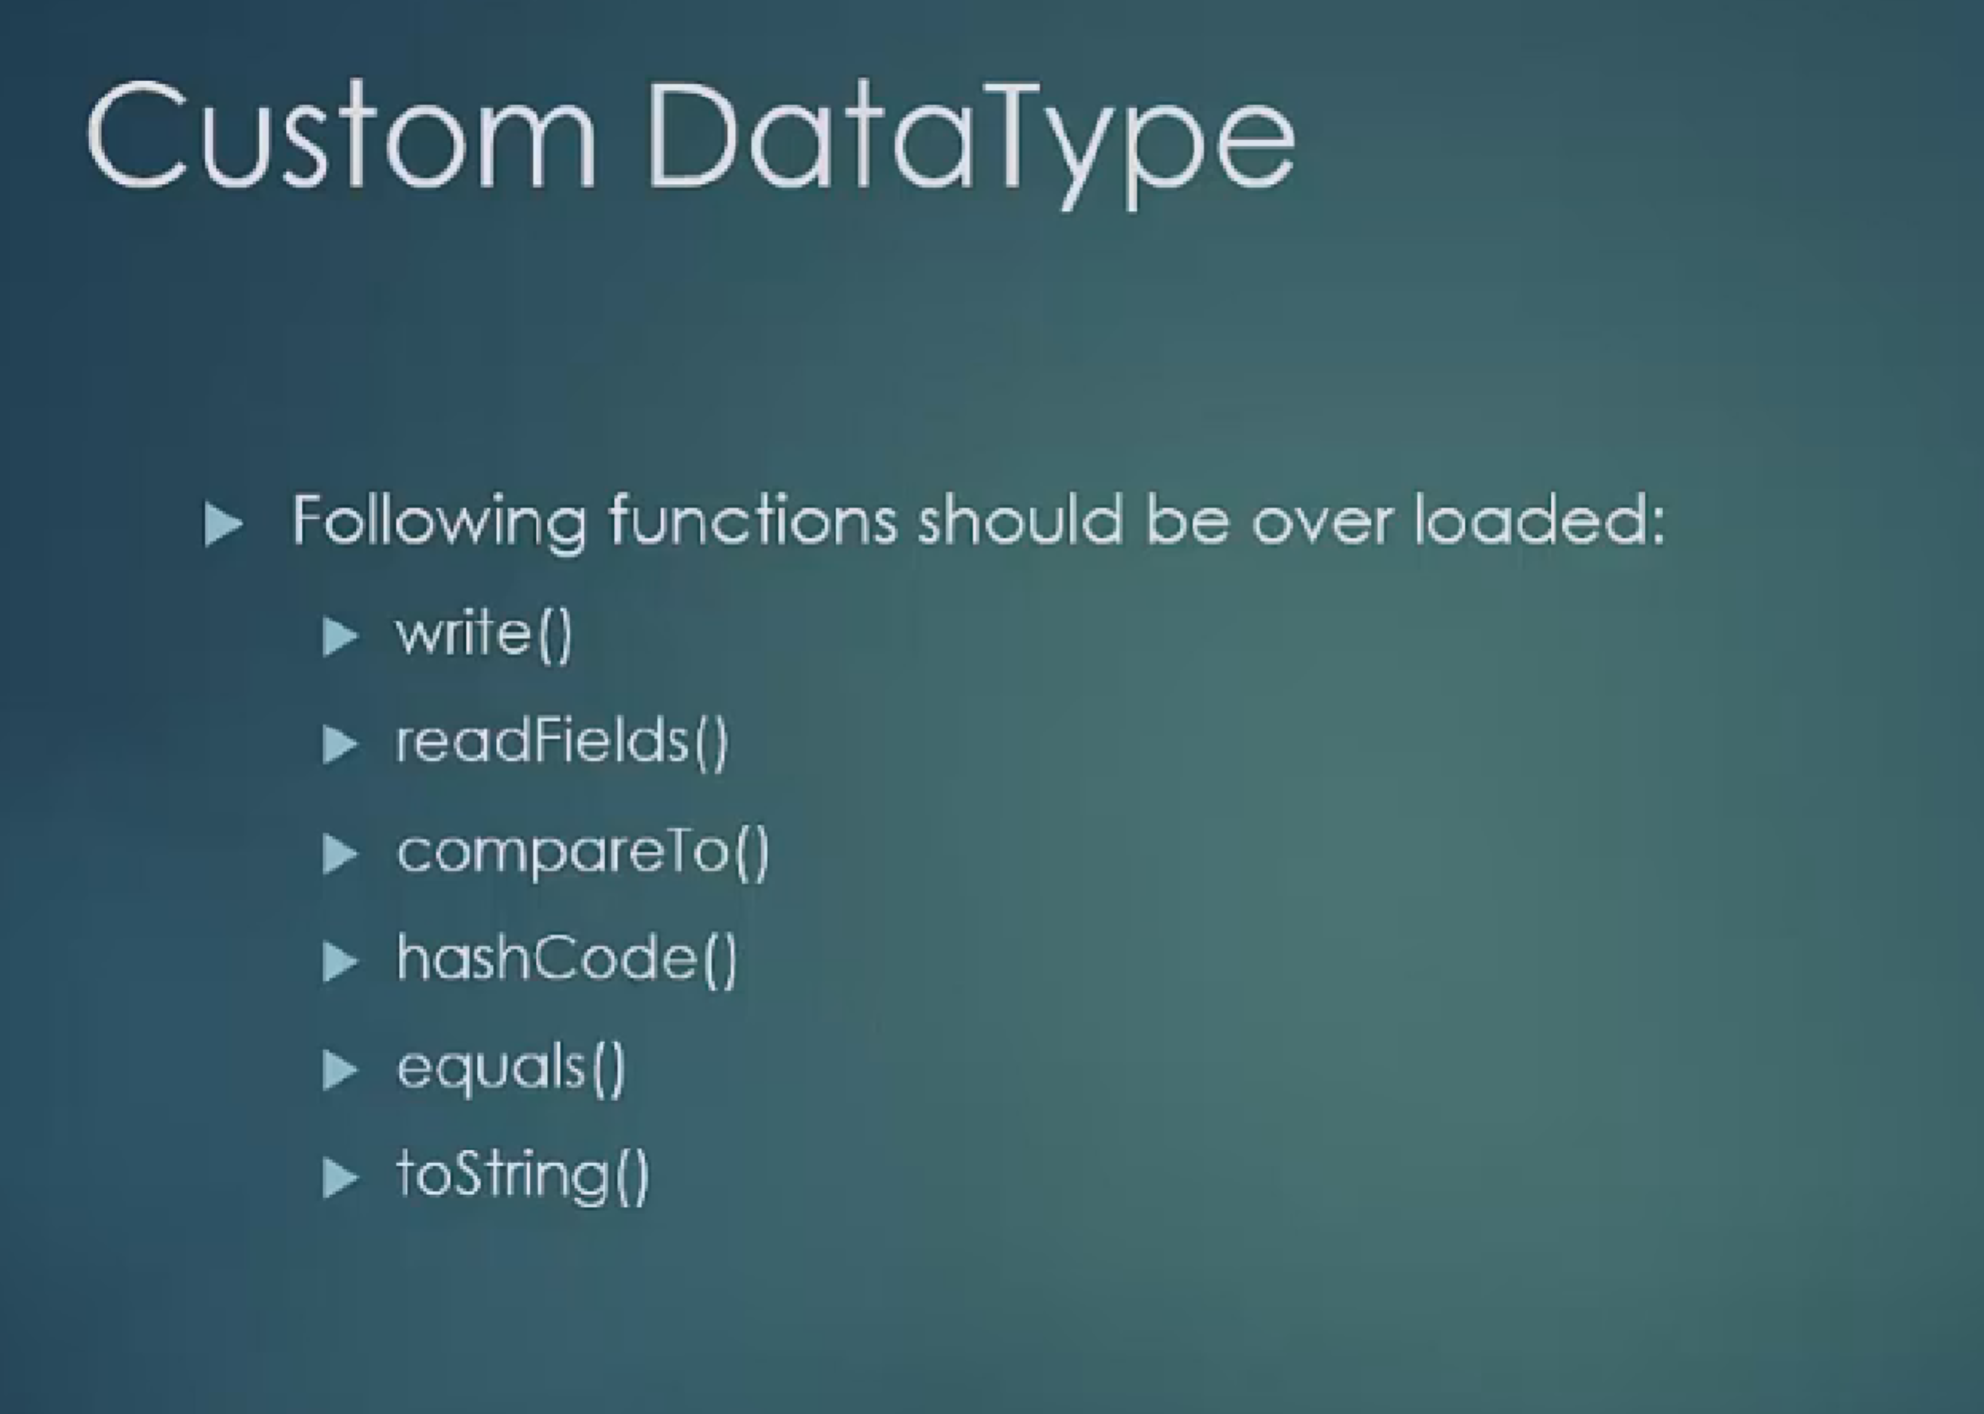

To convert int to IntWritable, use ‘new IntWritable(int)’. To convert IntWritable to int, use intWritable.get().

Likewise others except Text.

To convert String to Text, use ‘new Text(string)’. To convert Text to String, use ‘text.toString()’

You will be running MapReduce using below command

>>hadoop jar test.jar DriverCode inputfile outputfile

You need to specify type of inputfile as DriverCode, if it is other than TextInputFormat.

**Different types of Properties (Parameters)**

You can pass these properties as a command line argument when using ToolRunner or you can always set them through java code inside Job instance inside your Driver class.

e.g.

hadoop jar HadoopExperiments.jar <<DriverClass that uses ToolRunner>> -D mapred.reduce.tasks=0 <<input file path>> <<output file path>>

Space is required after –D, otherwise property will be passed to JVM instead of Hadoop.

mapred.reduce.tasks property -

It decides number of Reducers to be used.

mapred.map.tasks property -

Number of mappers is decided by InputFormat when it crates splits. Number of mappers is same as number of splits. You can increase number of mappers using this property, but cannot reduce it. The number of map tasks can also be increased manually using the JobConf's conf.setNumMapTasks(int num). This can be used to increase the number of map tasks, but will not set the number below that which Hadoop determines via splitting the input data.

mapred.min.split.size property -

In the default case, the DFS block size of the input files is treated as an upper bound for input splits. A lower bound on the split size can be set via mapred.min.split.size. Thus, if you expect 10TB of input data and have 128MB DFS blocks, you'll end up with 82k maps, unless your mapred.map.tasks is even larger.

You can define all these properties in Driver Class’ Job instance also.

**Standalone vs Pseudo distributed vs Fully distributed Deployment**

In Standalone deployment, all java processes like job tracker, task tracker etc runs on the same node and they share the same jvm.

In Pseudo distribution deployment, all java processes run on the same node, but on different jvms.

In Fully distributed deployment, name node is on different node, data node is on different node. So, job tracker and task trackers are on different nodes.

mapred.job.tracker property:-

In Hadoop, mapred-site.xml has a property mapred.job.tracker, which is initialized to localhost:<<port number>> for Pseudo-Distribution deployment.

You cannot change this property for Standalone deployment.

In Fully distributed deployment, this address will be pointing to some another machine where JobTracker java process is running.